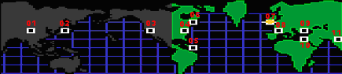
- ---
- ---
- ---
- ---
- ---
- Cash, Album, Scarab, Tut
- Chronograph,
- $5000,
- Cash, Album, Chalet
- Chalet, Cash, Album
- ---

